Herby Hertilien
ECE – 618
Dr. John
Poster Boards Project

- We are building a public posterboard website.
- Anyone can view boards and posters
- Only posters (logged-in users) can upload posters
- Posters are image-only
- Each poster shows:
  - the image
  - the board name
  - the date/time it was posted
- Posters can be shared using a URL
No comments, likes, or text posts.

2. Technology Stack – Implementation Plan
Backend (Python + Flask)
- Flask will be used to build a REST API that handles all application logic.
- The API will expose endpoints for:
  - viewing boards and posters (public)
  - uploading and deleting posters (authenticated users only)
How we’ll structure the Flask code
- routes/ = endpoints (URLs)
- services/ = business rules (ex: “only owner can delete”)
- repositories/ = database queries (CRUD)
- models/ = Board, Post, User tables

Example endpoints we will implement
- Public:
  - GET /api/boards
  - GET /api/boards/<board_id>/posts
  - GET /api/posts/<post_id>
- Poster-only:
  - POST /api/boards/<board_id>/posts
  - DELETE /api/posts/<post_id>
- The backend will be organized into routes (endpoints), services (business rules), and database models to keep the code clean and maintainable.
- Flask will also handle input validation, authentication checks, and error responses.

Containers (Docker)
- Docker will be used to ensure all team members run the same environment.
- A Dockerfile will package the Flask application and its dependencies.
- Docker Compose will be used during development to run:
  - the Flask API container
  - a PostgreSQL database container
- The same Docker image used locally will be deployed to the cloud, preventing environment-related issues.

Cloud (Google – free/student-friendly)
Google Cloud Run
- Cloud Run will host the Flask API by running the Docker container in production.
- Deployment will use the same container that was tested locally.
- Cloud Run will provide a public URL for accessing the application.
Google Cloud SQL (PostgreSQL)
- Cloud SQL will store application data such as boards, posters, and users.
- The Flask API will connect to the database using environment variables.
- This mirrors the local PostgreSQL setup used in Docker Compose.
Google Cloud Storage
- Cloud Storage will store uploaded poster images.
- When a poster is uploaded, the backend will:
  - upload the image to Cloud Storage
  - save the returned image URL in the database
- This separates image files from application data for better performance and scalability.
This stack allows us to develop locally with Docker, deploy the same Flask application to Google Cloud Run, store structured data in Cloud SQL, store images in Cloud Storage, and maintain a clean N-tier architecture.

3. N-Tier Architecture (High-level design)
Conceptual Diagram (Architecture)
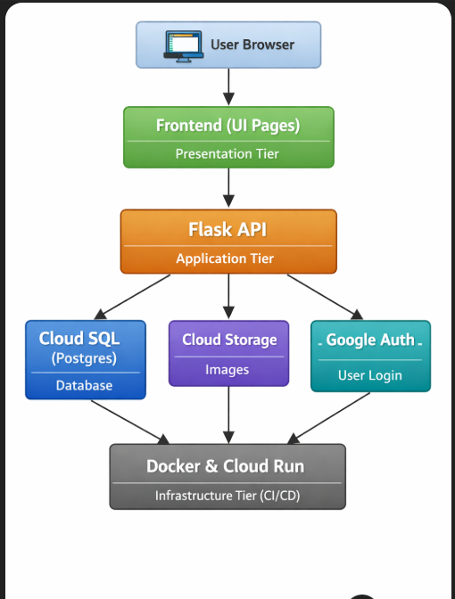

Explanation
- Presentation Tier: frontend pages users see
- Application Tier: Flask API (rules, auth, uploads)
- Data Tier: database + image storage
- Infrastructure Tier: Docker + Cloud Run + CI/CD

4. Repository Structure
This structure directly supports N-tier architecture, testing, and deployment.
posterboard/
│
├── backend/
│ ├── app/
│ │ ├── routes/ # API endpoints (controllers)
│ │ ├── services/ # business logic
│ │ ├── repositories/ # database access
│ │ ├── models/ # SQLAlchemy models
│ │ ├── auth/ # authentication logic
│ │ ├── config.py
│ │ └── __init__.py
│ │
│ ├── tests/ # pytest tests
│ ├── Dockerfile
│ ├── requirements.txt
│
├── frontend/ # UI pages (React or Flask templates)
│
├── infra/
│ ├── docker-compose.yml # local dev (API + DB)
│ └── cloudrun/ # deployment notes
│
├── docs/
│ ├── diagrams/ # architecture, ERD, sequence diagrams
│ ├── api/ # endpoint documentation
│ └── project-plan.md
│
└── .github/
└── workflows/
└── ci.yml # tests + deployment
How this maps to N-tier
- Frontend → Presentation tier
- routes + services → Application tier
- repositories + models → Data tier
- Docker + Cloud Run → Infrastructure tier

5. Data Model
ERD
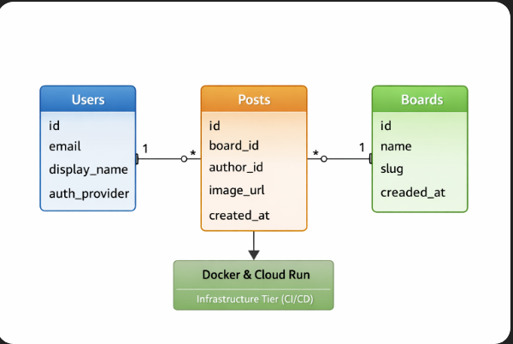

6. URL Structure (Sharing posters)
Public URLs
/boards
/boards/{board_slug}
/boards/{board_slug}/posts/{post_id}
API URLs
GET /api/boards
GET /api/boards/{board_id}/posts
GET /api/posts/{post_id}
POST /api/boards/{board_id}/posts (login required)
DELETE /api/posts/{post_id} (owner only)
This gives us clean, shareable links.

7. Authentication (Who logs in?)
- Public users: no login needed
- Posters: must log in to upload/delete
Auth choice
Login with Google
- No passwords
- Faster implementation
- Easier security explanation

8. Poster Upload – Sequence Diagram
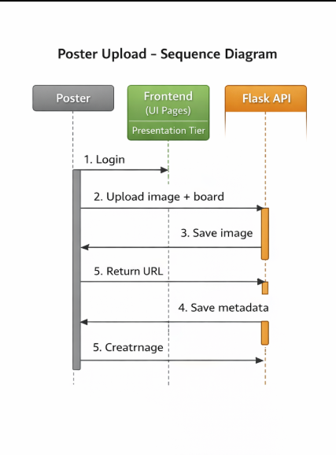

9. Deployment Diagram
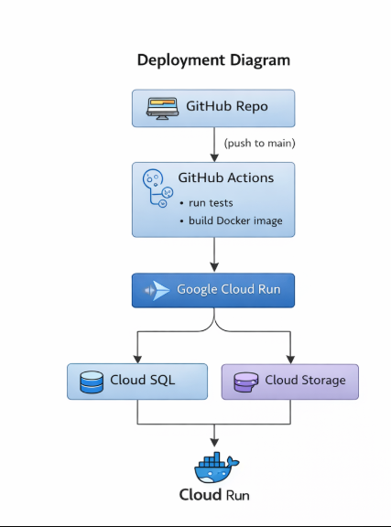
10. Testing Plan
What we test
- Public can view boards and posters
- Upload requires login
- Only owner can delete
- Non-image files rejected
- Health endpoint works
How
- pytest
- Flask test client
- Tests run automatically in CI

11. MoSCoW Requirements
MUST
- View boards
- View posters
- Shareable links
- Login for posters
- Upload posters
- Delete own posters
- Docker deployment on Google Cloud
- Automated tests
SHOULD
- Pagination
- Validation
- Logging
COULD
- Poster profiles
- Tags
- Analytics
WON’T
- Comments
- Likes
- Private boards
- Text posts

12. Sprint Breakdown
Sprint 0 – Setup
- Repo + Docker
- Flask skeleton
- Health endpoint
- Seed boards
Sprint 1 – Public Browsing
- DB schema
- View boards/posters
- Shareable URLs
- Architecture + ERD diagrams
Sprint 2 – Upload & Auth
- Google login
- Upload posters
- Ownership rules
- Sequence diagram
Sprint 3 – Deployment
- Cloud Run
- Cloud SQL + Storage
- CI/CD
- Final demo

13. Team Responsibilities
Content
- Create poster images
- Define boards
Backend
- API
- Database
- Auth
- Upload logic
Frontend
- Board pages
- Poster grid
- Upload page
DevOps
- Docker
- Cloud setup
- CI/CD
Scrum Master
- Planning
- Task tracking
- Diagram coordination
- Integration oversight

14. Summary
We’re building a Dockerized Flask posterboard app with public browsing, authenticated uploads, Google Cloud deployment, automated tests, and clean N-tier architecture.

